File Organization Techniques

HARIRAJ G

230701104

Single-Level Directory Structure

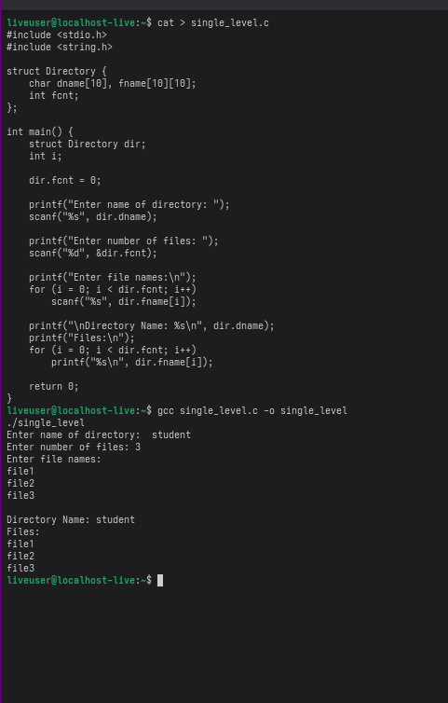

Two-Level Directory Structure

